**The Christmas Tale**

Of the Gerbils in the lab

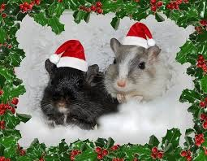

Happy Holidays!!!

Happy Holidays!!!

Darkness. Mrs Clark switched of the lab lights on Christmas Eve and returned home. No one was left in the lab except for Liquorice and Butterscotch.

They chewed at the bars on their huge cage door. Tonight, of all nights, it swung open and they scurried carefully out like thieves on a heist.

For hours they tiptoed around the room they endlessly watched but never got the chance to roam around in. DING! The ancient clock stroke twelve and Liquorice and Butterscotch dashed up onto the wooden windowsill. Then a miraculous thing happened. Santa Claus flew past the tinted class and, just at that moment, the excited gerbils leaped into his mahogany slay.

They flew with him and his hardworking crew of reindeer all around England delivering neatly wrapped presents. Liquorice and Butterscotch then scurried up Santa’s crimson suit and perched on there they whizzed around the globe, giving gifts to the good children but delivering coal to the bad ones. The cute little fur-balls had the time of their lives, but it had to end.

Santa propelled them back to the lab, said his farewells and left in a green flash of light. They ran back to their cage overjoyed and slept after a long, hard night.

January came sooner than expected, along with the start of term. Mrs. Clark entered the room, unsuspecting of their adventure.

No one knows this except me, and that is because I, too, took a merry ride with Santa that night.